IOT Based Automatic Vehicle Accident Detection and Rescue System
The rapid rise of technology and infrastructure has made our lives easier. The high demand of automobiles has also increased the traffic hazards and road accidents. Life of the people is under high risk. The delay in reaching of the ambulance to the accident location and the traffic congestion in between accident location and hospital increases the chances of death of the victim. To overcome this problem our automatic ambulance rescue system comes to the rescue. This proposed IOT based accident detection system helps to reduce the loss of life due to accidents and also reduces the time taken by the ambulance to reach the hospital. To detect the accident there is accelerometer sensor present in this rescue system and the GSM module included sends messages about the location to the respective guardian and rescue team. With the help of accelerometer sensor signal, a severe accident due to an obstacle can be recognized. Microcontroller used, sends the alert message through the GSM module including the location to guardian or a rescue team. So, the emergency help team can immediately trace the location through the GPS module, after receiving the accident location information, action can be taken immediately. This accelerometer based accident detection system is powered by Atmega 328 microcontroller it consists of display, accelerometer sensor, GSM module and alarm. This automatic ambulance rescue system project is useful in detecting the accident.

Block Diagram:

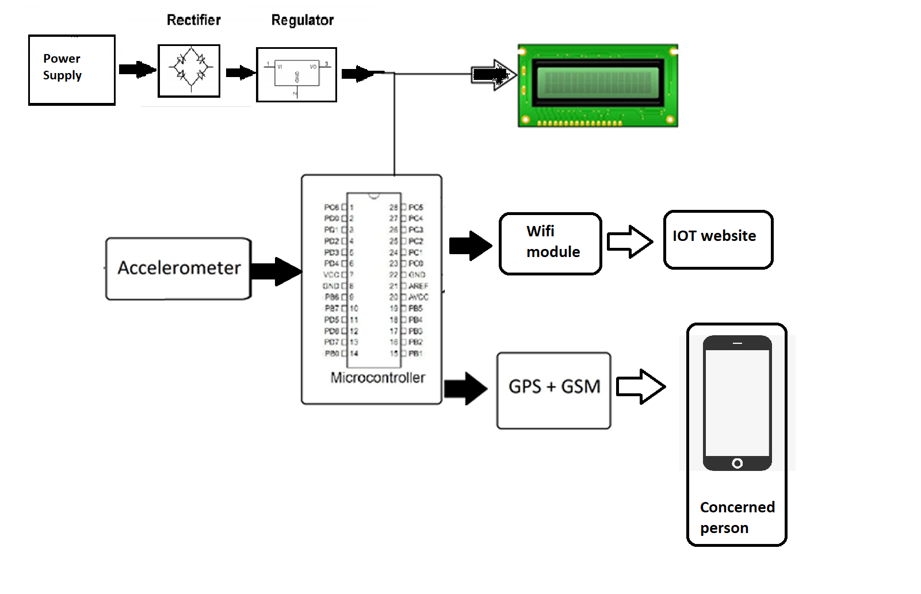

- Hardware Specifications

- Atmega 328 Microcontroller

- GSM Modem

- Accelerometer Sensor

- Wifi modem

- Crystal Oscillator

- Resistors

- Capacitors

- Transistors

- Cables and Connectors

- Diodes

- PCB and Breadboards

- LED

- Transformer/Adapter

- Push Buttons

- Switch

- IC

- IC Sockets

